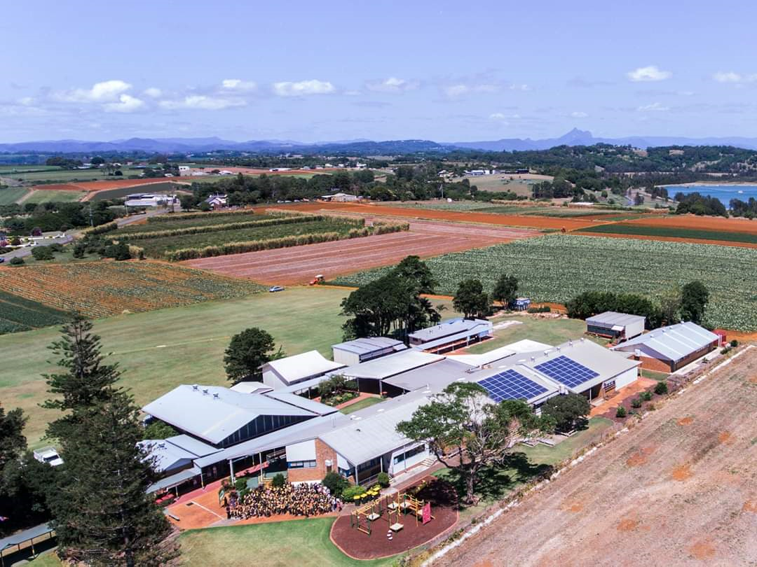
11 Collier Street
Cudgen NSW 2487
Phone: (02) 6674 1287
Email: cudgen-p.school@det.nsw.edu.au
Web: https://cudgen-p.schools.nsw.gov.au/

Welcome to Cudgen
PUBLIC SCHOOL
CUDGEN
School Information
Growth
Cudgen
Primary
School
ENROL NOW FOR
2006
Growth
Cudgen
Primary
School
ENROL NOW FOR
2006
CONTENTS

- Principal’s Message ….…………………………………………….. Page 03
- School Staff ………………………………………………………..… Page 04
- School Vision Statement …………………………………............. Page 05
- Information for Parents ………………………………………….... Page 06
4.1 School Environment ………………………………………... Page 06 to 08
Students Community
School Staff Canteen
Parents and Caregivers Parents and Citizens Association

  - Enrolment Procedures / Requirements ………………………… Page 09
Students with special needs Part-time Enrolments
Short-term and Part-time Attendance Refusal of Enrolment

4.3 School Practices and Procedures ……………………….. Page 10 to 13
Bicycles and Toy Vehicles School hours Bell times
Bus Travel To and From School Hazards
Leaving the School Area Uniforms
Library Voluntary School Contributions Lost Property When Your Child is Away From School Medicine at School Weekly Timetable
Permission Notes

  - Student Health ……………………………………………….. Page 14 to 15
Immunisation Ringworm and Impetigo
Head Lice North Coast Area Health Service

- Beginning School …………………………………………………... Page 16
Be Ready for School
What Else You Can Do

- Positive Behaviour for Learning ………………………….. Page 17 to 18
School Fair Discipline Code
Promoting a Happy and Safe School

- What Children Learn ………………………………………... Page 19 to 21
Six Key Learning Areas
Computer education Program
Other Programs
1. PRINCIPAL’S MESSAGE

At Cudgen Public School we help our students discover their innate talents and unlock their full potential within the context of a supportive and nurturing environment. Our dedicated teachers deliver outstanding and innovative learning programs, inspiring our students to imagine the possibilities, believe in themselves and create their brightest future. Each and every Cudgen student is known, cared for and valued as an individual. We offer a first class education that is uniquely personalised, uniquely collaborative and uniquely amazing.
At Cudgen Public School, we offer a wide range of opportunities to support our students’ learning – physically, social-emotionally, cognitively and creatively. To achieve a high expectations culture which fosters student growth, Cudgen Public School:
- values excellence in teaching and learning;
- offers students rich and innovative opportunities for learning and leadership; and
- actively promotes student wellbeing, resilience and positive relationships.
We hope that this information booklet provides an insight into our unique school culture, our educational experiences and also helps to showcase our achievements. Relationships between our families and our school are vital to the success of our students, I encourage you to become involved in every way possible. We are so very proud of our school; welcome to Cudgen!
With warm regards,
Renee Beach

2. SCHOOL STAFF and P&C

PRINCIPAL: Renee Beach

ASSISTANT PRINCIPALS: Rod Cornelius
Linda Joulian

TEACHING STAFF: Catherine Togo
Emma Star Webb
Shanene Phillips
Linda Joulian
Emma Harding
Amber McEwan
Brooke Houlahan
Dane Baxter
Rod Cornelius
Elisa Laurie

LEARNING AND SUPPORT : Delinda Hall
Brooke Houlahan

RFF: Elisa Laurie
Emma Star Webb

LIBRARIAN: Dee Punch

SCHOOL LEARNING SUPPORT OFFICERS: Tanya Walmsley
Tina Palmer
Kristine King

COUNSELLOR: Ben Bramston
RELIEVING SCHOOL ADMIN MANAGER: Kathy Roberts
REILIEVING SCHOOL ADMIN OFFICE: Anne Davidson

GENERAL ASSISTANT: Shawn McKnight
CLEANER: Grant Wilcock

P & C:
President: Gemma Martin
Vice President: Sue Togo and Jacinta Myles
Secretary: Katie Thornton
Treasurer: Kylie Hecksher

Assistant Secretary:
Uniform Convener: Belinda Butler
Uniform Assistant: Linda & Kim Slockee
Canteen Convener:
Canteen Assistant: Anne Davidson
Canteen Roster: Gemma Martin
Fete Convener:

3. SCHOOL VISION STATEMENT

Cudgen Public School is an inclusive school community, rich with culture and history and set on Bundjalung land. Our educators work collaboratively with a strong focus on equity and excellence. The shared expectation is that every student reaches their potential. Student success is underpinned by engaging and explicit instruction from passionate and committed teachers.
At Cudgen Public School we help our students discover their innate talents and unlock their full potential within the context of a supportive and nurturing environment. Our caring educators deliver outstanding and innovative learning programs, inspiring our students to imagine the possibilities, believe in themselves and create their brightest future.
Each and every Cudgen student is known, valued and cared for. We offer a quality education that is uniquely personalised, uniquely supportive and within a unique learnscape. At Cudgen Public School, our students are at the heart of all that we do.
.

School Leaders – 2021
Sienna, Ethan, Sydney & Emile

4. INFORMATION FOR PARENTS

4.1 SCHOOL ENVIRONMENT

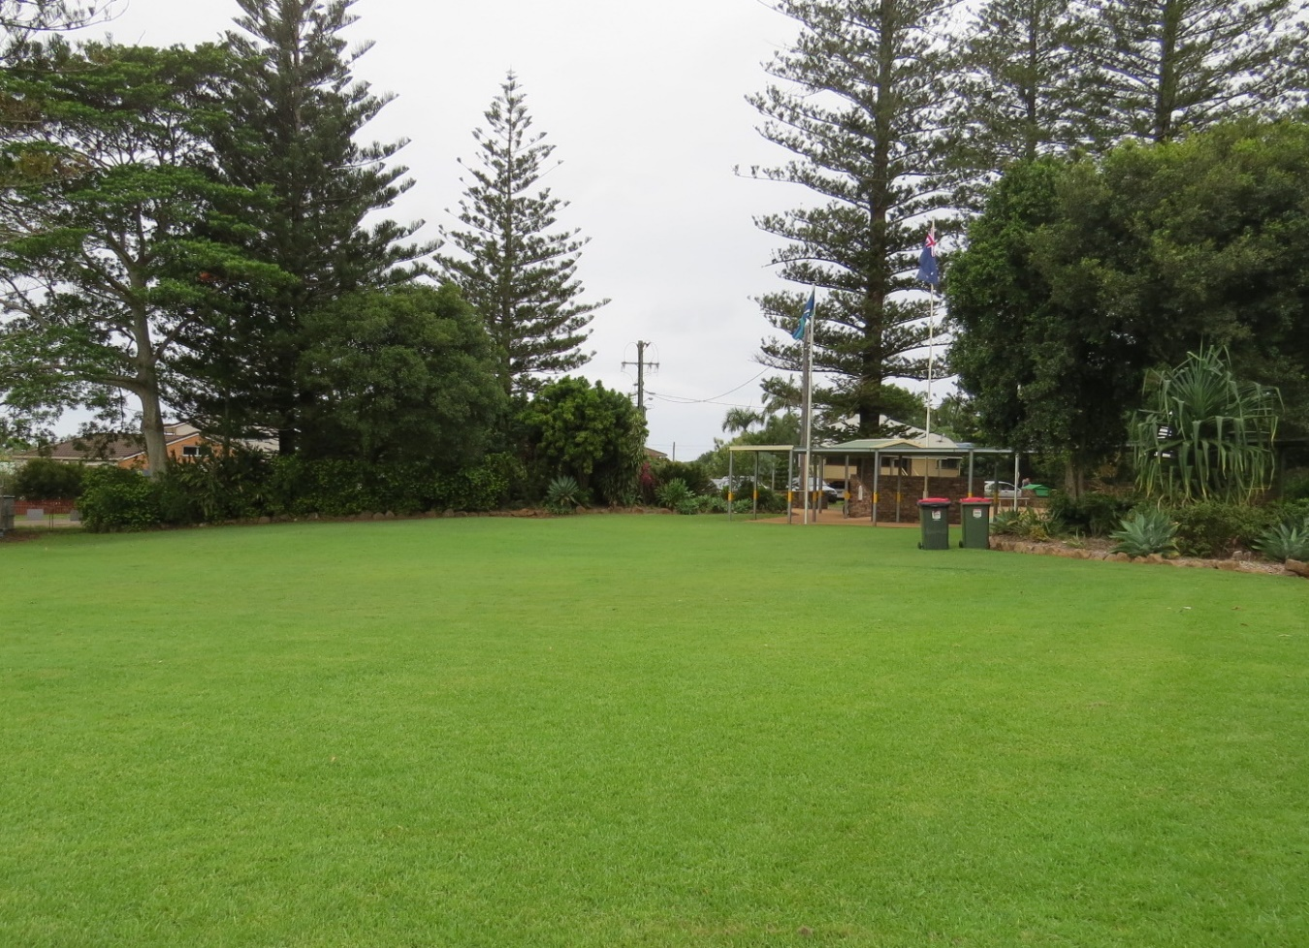
Cudgen is a semi-rural community 14 kilometres south of Tweed Heads. Our school is set on a hill overlooking Kingscliff and the Pacific Ocean. This most peaceful and picturesque setting is unique. Norfolk pines stand proudly at the front of the school and serve as a landmark when pointing out the school’s location.

STUDENTS

Our students are our most important asset. As an absolute priority we aim to provide interesting and meaningful learning programs which recognise individual stages of development and which also allow students to pursue interests and talents, allowing potential to be reached. We nurture self-esteem, encourage caring treatment of others and guide our students towards responsible self-direction. We also plan to give all students opportunities to experience success.

SCHOOL STAFF

Teachers and Administration staff are dedicated, highly qualified and committed to working with students, parents and community in a spirit of collaborative co-operation. We believe it is a priority to continue developing our professional skills so as to keep abreast of current educational trends and school administration. Teaching staff are always willing and available to discuss the progress and welfare of students and the programs we provide. The front office is also more than happy to answer your enquiries (please note the office is open for business from 8.30 am). Our school is committed to meeting the needs of individual students and provides professional speech therapy, occupational therapy and psychological support.

PARENTS and CAREGIVERS

Our school encourages and greatly appreciates the support and involvement of parents and community members. They play a vital role in the success of the school and in supporting students to achieve their best. Parents will be informed regularly of their child’s progress and general welfare. School and community news is conveyed via a fortnightly newsletter, Sentral Parent Portal, school website, school facebook page and Class Dojo.

COMMUNITY

We recognise the importance of our school as a place for our school community to meet. Our Parents and Citizen’s Association (P & C) is the forum for parent meetings and provides much valued support to our school. Parent and community members are always welcome and their participation and involvement in programs is valued.
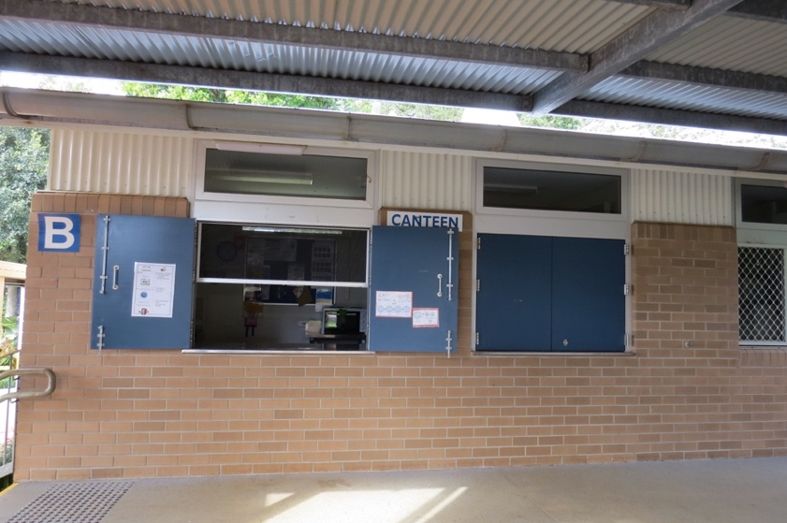
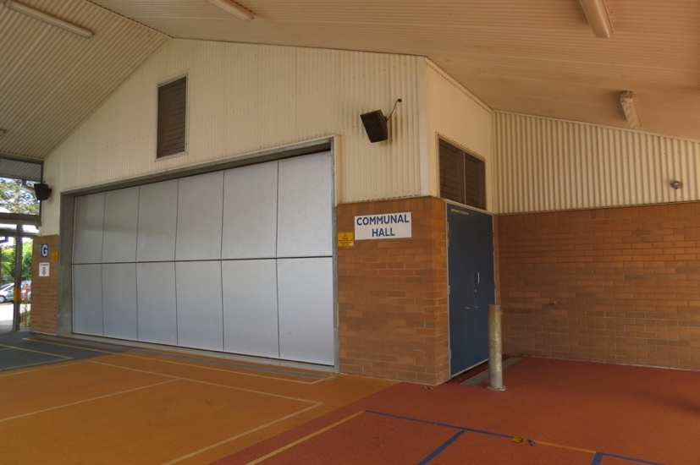

OUT OF SCHOOL HOURS CARE

Aussie Kids Fun & Fitness would like to welcome families to service. They offer before school, after school and vacation care. They will be operating from our school hall.
Before School Care Monday to Thursday – 6am to 8.30am (subject to change based on demand) and After School Monday to Friday 3pm to 6pm. Pupil free days and school holidays 6.30am till 6pm. Contact Kim on 0413 974775.

CANTEEN

- Operates Monday and Friday

- Lunch orders can be ordered on line using the App QKR! (pronounced ‘quicker’). Alternatively, lunch orders must be written on your own bags then brought to school and placed in class lunch order container

- Canteen opens at recess selling healthy snacks

- After lunches have been eaten (1.15 p.m.) children will have the opportunity to purchase fruit, ice blocks, drinks etc

Parent volunteers supervise the canteen on a Monday and Friday. We are always thankful for helpers in this area. If you have some free time to commit to your child’s school we would appreciate you seeing the office and getting your name on the roster.

We aim to maintain a ‘healthy canteen’ in line with regulations provided by the NSW government.

Linked with this healthy canteen we run a nutrition program directed towards promoting healthy eating habits in children. We encourage children to have a healthy fruit snack in the morning – through our fruit break. Children who have a fresh piece of fruit (from home) can eat this in class at a specified time whilst still working. This we have found greatly increases the amount of fruit our students are eating, especially the little ones. An added advantage is the improved student concentration levels that we have noticed since starting this initiative.

PARENTS AND CITIZEN’S ASSOCIATION

P & C meetings are held on Wednesday nights at 6pm in week 3 and week 7 of each term. These meetings provide parents with an opportunity to share information about children and to voice opinions, ideas and requests. They are also an opportunity for the school to request support and to consult with the community and parent group on important matters.

P & C raise valuable funds and provide enormous support to the school. You are encouraged to become actively involved by attending meetings or assisting P&C activities. To fully participate in meetings a small joining fee of one dollar is required. A P&C representative will attend kindergarten orientation day to assist with further inquiries.

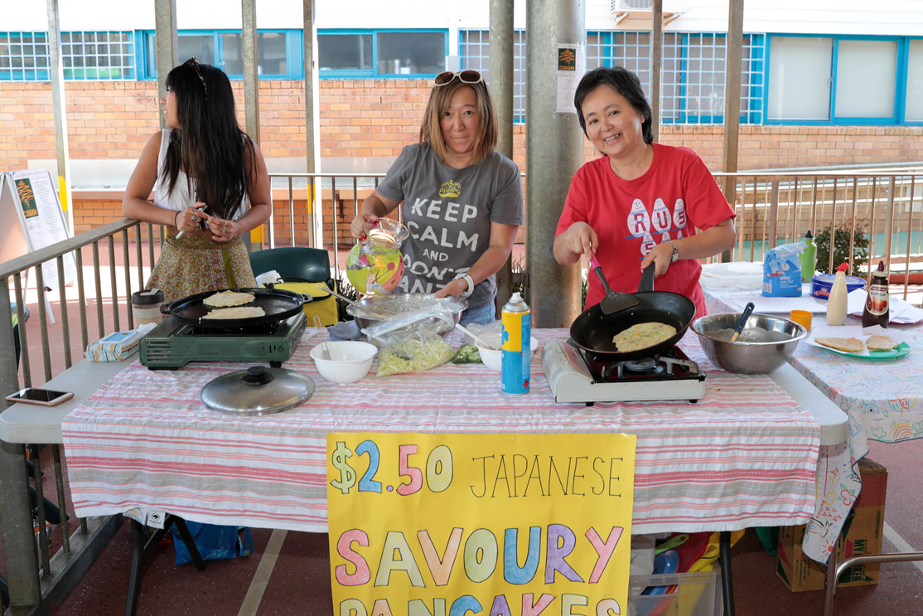
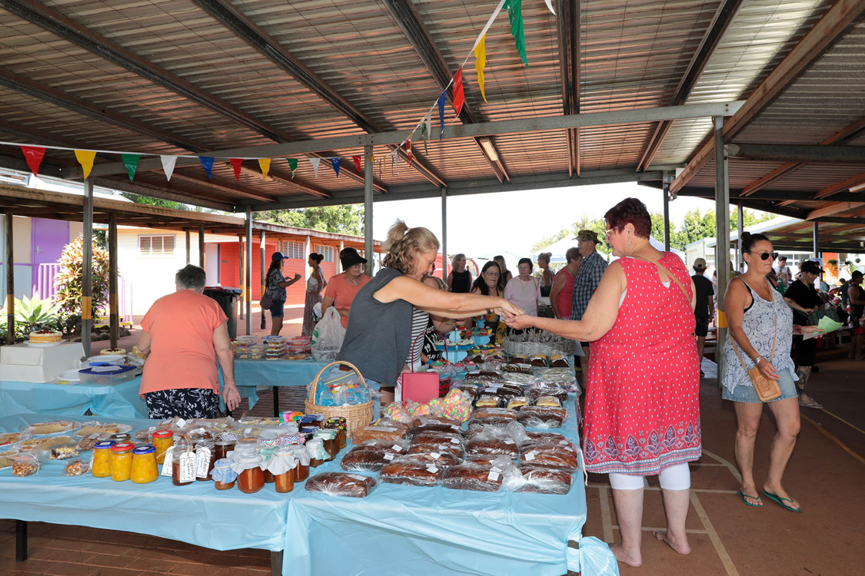

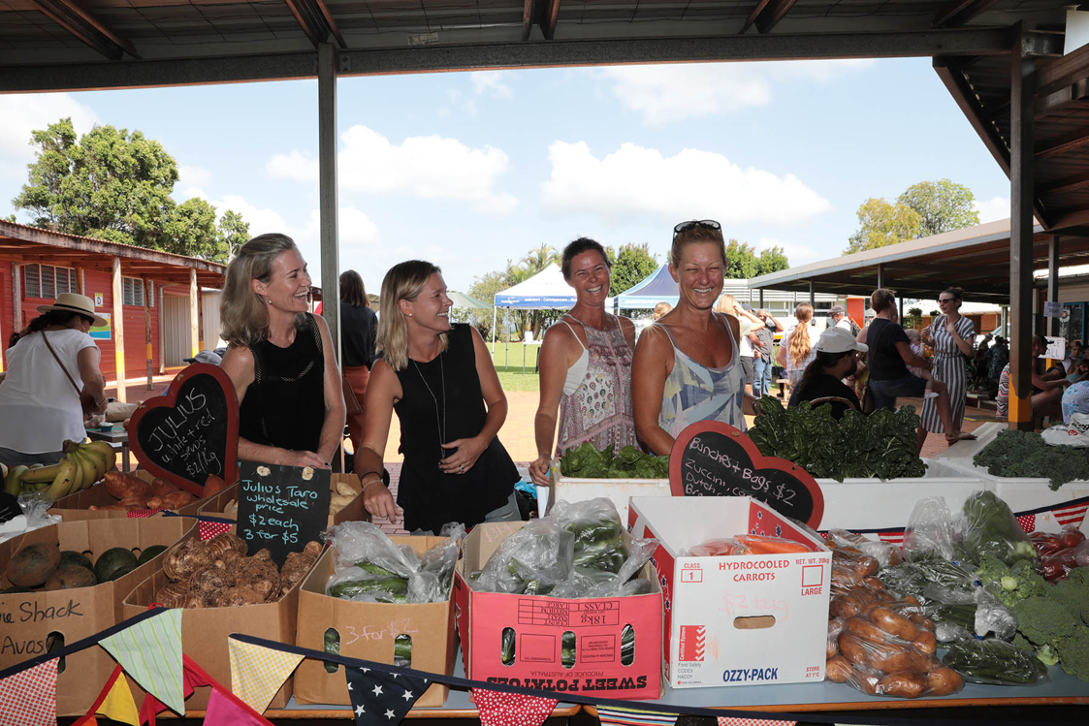

“The parent community pulling together”
4.2 ENROLMENT PROCEDURES/REQUIREMENTS

Our school follows Department of Education policies and procedures. Parents enrolling their children complete an Enrolment Form which provides the school with important information. If you change your workplace, emergency contact telephone number, home telephone number or address, please inform us immediately.

Enrolment at this school is only offered to students living in the Cudgen zone. Out of Zone applications may be considered by submitting a non-local enrolment application form with one or more of the criteria applying.

Children may start Kindergarten at the beginning of the school year if they turn five years of age on or before 31st July in that year (earlier enrolment may be negotiated with the principal). Kindergarten children will start the school year after an individual Best Start assessment.

Proof of age, such as a birth certificate or passport and 100 points of proof of residence is required upon enrolment.

Parents are required to provide documented evidence of a child’s immunisation status on enrolment. Students not immunised will be required to stay home for the duration of an outbreak of a vaccine preventable disease. Please contact your school if you require any support with these requirements.

ENROLMENT OF STUDENTS WITH ADDITIONAL LEARNING SUPPORT NEEDS
Parents of children with special needs should see the principal in order to find out about services and resources available to support students starting school. An appraisal of the child’s needs can be undertaken to ensure that we are catering for the student’s specific needs. If you require information about this please consult with the principal who will co-ordinate with the Learning Support Team to ensure that we address your child’s learning needs. An early intervention team linked to Tweed Heads Hospital is available to assist parents/caregivers with the transition from home to school.

HIGH POTENTIAL AND GIFTED EDUCATION
The High Potential and Gifted Education policy applies to all NSW public schools. It describes a framework at our school that develops the talent of high potential and gifted students. We promote engagement and challenge for every student across intellectual, creative, social, emotional and physical domains of potential.

PART TIME ENROLMENTS
Consultation with the principal is required for part-time enrolment.

4.3 SCHOOL PRACTICES AND PROCEDURES

BICYCLES / TOY VEHICLES
If children are to ride bicycles to and from school their parents must be confident that their children know the rules of the road. It is compulsory by law that any cyclist must wear a safety helmet. It is also important to regularly check your child’s bicycle and make sure it is in good working order.

It is recommended by Road Safety Authorities that children under the age of 10 should not ride unsupervised on roads. Although they may be able to ride their bike well, they have not developed peripheral vision to a degree that they can really monitor the traffic around them to a level that they are really safe.  Our school strongly discourages skate-boards, in-line skates, roller skates, shoes with roller balls, scooters or any other toy vehicles. Safety reasons and the fact these items are hard to keep secure at school make them difficult to manage. | 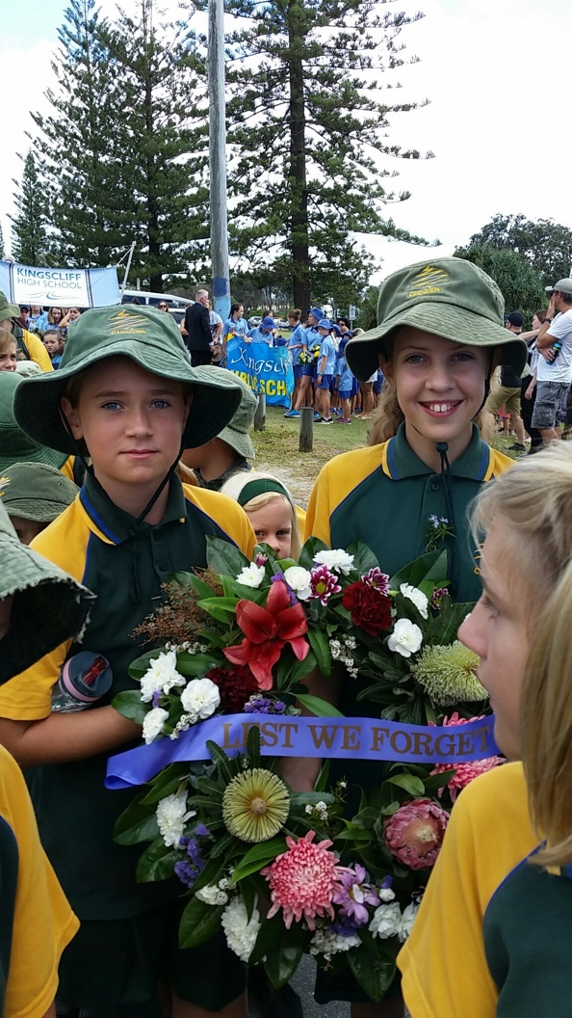

BUS TRAVEL
Surfside Bus Co. (telephone (07) 5571 6555) has five services to and from our school.

- Chinderah
- Kingscliff
- Old Bogangar Road
- Kingscliff Estate
- Pottsville

J and B Charter Bus (John Singh, telephone 0427 453 091) has one bus service between our school and Duranbah.

The buses drop the children at school each morning. Each afternoon, teachers on bus duty supervise the boarding of all buses. All Kinder/Yr 1/Yr 2 students are eligible for free transport irrespective of distance from home to school. Primary students Yr 3 to Yr 6 are eligible only if they reside more than 1.6 km radius from school. Applications for free bus travel must be completed online via apps.transport.nsw.gov.au/ssts/home#/howToApply

LEAVING SCHOOL AREA
No students are to leave the school grounds without permission. Children wishing to leave the playground during the day must bring a note from a parent or care provider. The permission note is to be received by a teacher who will notify the office. The school will contact parents if a child is unwell and needs to go home. Please phone the office in emergencies when a note is not provided.

LIBRARY
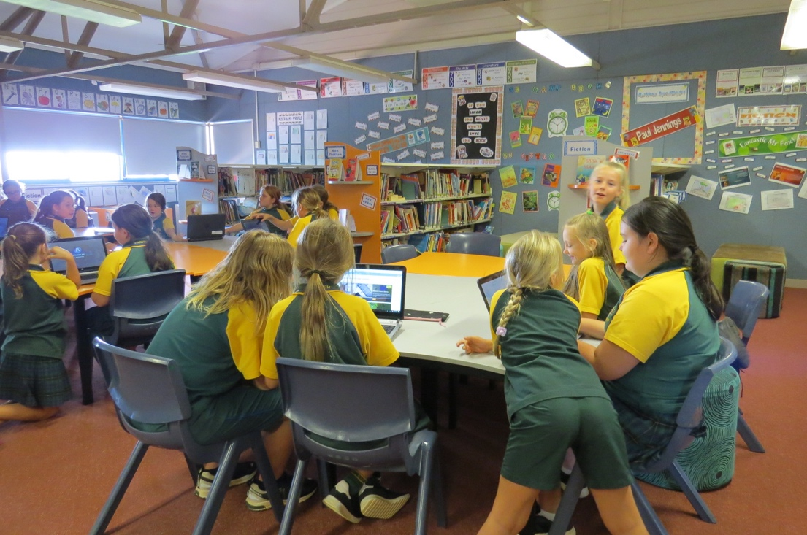
Children are encouraged to take advantage of the ever-increasing range of literature our library offers. Each class has a library lesson and may also visit the library some lunch-times. It is preferred that students use library bags to help protect valuable books.
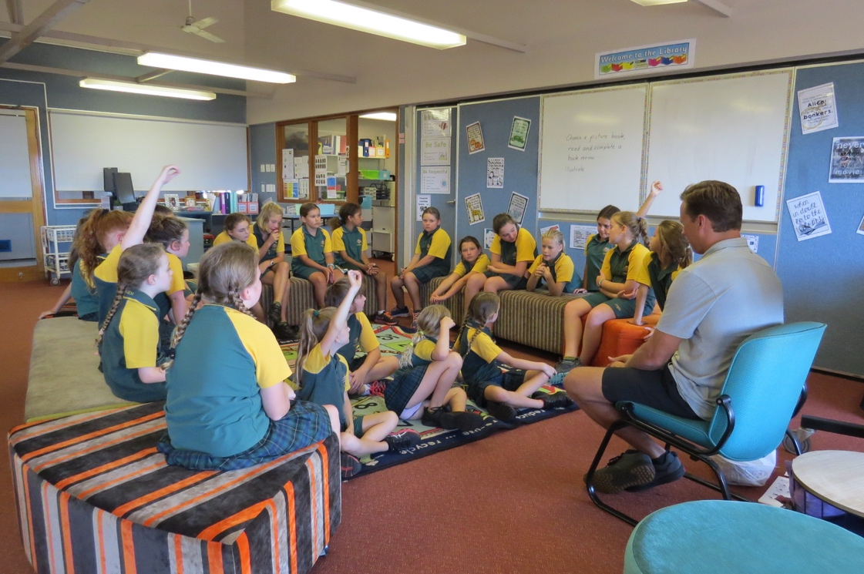

LOST PROPERTY
Enquires for missing items should be directed to the office. Most instances of lost property would be overcome by clearly labelling all your child’s possessions including all clothing, school bag, lunch box, drink bottles, even ruler and pens etc.

MEDICINE AT SCHOOL
NSW Department of School Education Policy states that the school office is to be informed by parents/caregivers in all cases of students bringing prescribed medicines to school. The principal must receive written authorisation by the student’s doctor or parent/guardian if medicines are required to be dispensed at school. Parents should seek assistance from the office on this matter. For safety reasons all medicine must be handed in to the front office and the office staff will manage.

PERMISSION NOTES
Parents/caregivers will be required to complete permission notes for a school excursion or outing that their child may be attending. A copy of permission notes can be found on our school website.

SCHOOL HOURS – BELL TIMES

(Recess and Lunch times can change from year to year).

Lessons commence 8.55 a.m each day
Lessons conclude 2.55 p.m each day
Morning recess 10.55 a.m -11.20 a.m.
Lunch 1.05 p.m - 1.55 p.m.

Pupils should not arrive at school before 8.30 a.m. The school cannot be responsible for the supervision of pupils before 8.30 a.m. or after 3.15 p.m., except for special circumstances such as excursions or late bus arrival. If you need to drop your child off before 8.30 please contact the principal for approval. Please also remember the time difference between states during daylight saving.

TO AND FROM SCHOOL HAZARDS
Staff do not have any direct supervision responsibility beyond the school grounds. The following hazards are those that the school would like parents and caregivers to be aware of.

Hazards | Safe Practice
Loitering | Walk straight home along the most direct route.
Expected time of arrival | Parents should know this route. Do not vary it and children can be home on time.
Strangers | Don’t talk to strangers. Walk along footpaths away from roadways.
Traffic | Do not walk near cars or buses outside the school, especially behind them.
Bikes | Wear a safety helmet. Children should ride only when they are old enough to obey road rules and use bikes responsibly. Children walking should keep an eye out for pushbikes when crossing roads. Pushbikes are to be maintained in a safe state of repair.
Lifts in cars | Do not accept a lift home unless you have permission from your parents. Parents should inform the school when home / school routines are varied.
Roadways | Remember road safety rules when crossing roads.
Traffic Lights  Buses | Remember road safety rules at traffic lights.  Obey the Bus Code of Behaviour.
UNIFORMS  The Department of Education supports the wearing of a school uniform in NSW Public Schools. Wearing a uniform is a way of saving money and promotes a feeling of belonging to and displaying pride in our school.  A broad brimmed hat is a compulsory aspect of our school uniform for outdoor play.  Our uniform shop is open by appointment and is located on the outside of the school building just past the office. To make an appointment please contact Belinda on 0402 114 457.  Orders are made via the Qkr App. |  | 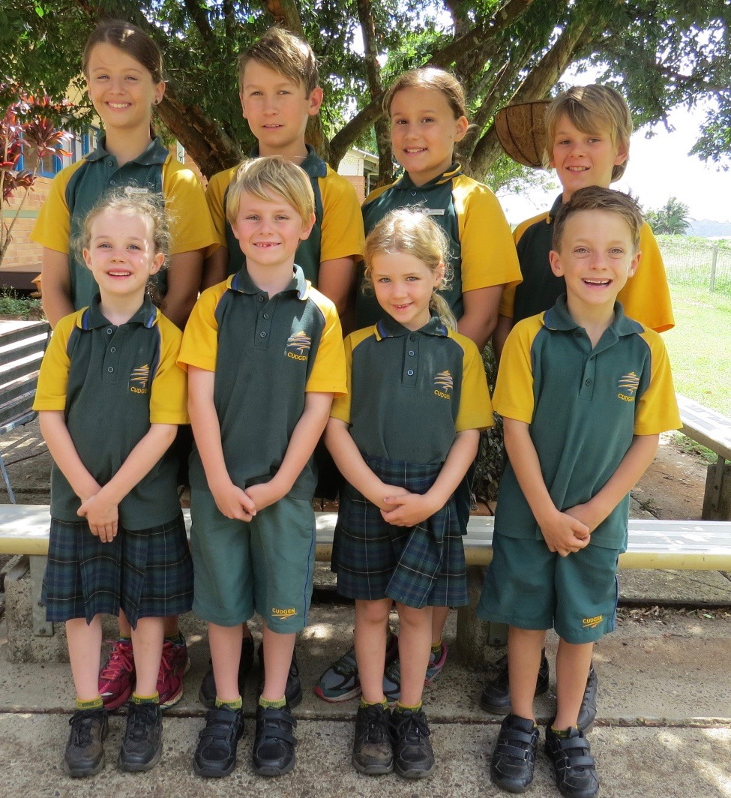

VOLUNTARY SCHOOL CONTRIBUTIONS
In consultation with our schools P and C we do seek from parents and carers a general school and text book contribution. Funds raised through these contributions will be used to supplement educational programs and resources within our school and provide students with the texts that their class will be using. Payment of the general school contribution is a decision made by parents and caregivers and is entirely voluntary. However, our school greatly values your contribution as this will significantly assist us in ensuring your students have the best resources to support their learning.
The contributions can be paid at the school office or via the Parent Online Payment found on the school website, in full or by instalment.

General Levy $35 per child
Resources $45 per child

No embarrassment or discrimination will occur in our school as a result of late payment of contributions.
Support and payment options are available for families in need. Please contact the principal for a confidential discussion in cases of financial difficulties.

WHEN YOUR CHILD IS AWAY FROM SCHOOL
A note must be provided when your child is absent. This should be done on the day after a child is sick, prior to leave (eg. funeral, family matters) or within four days when leave is going to be extended. Also, please notify the school if your child is going to be away for more than four days. Teachers are required to mark absences showing part or full days. All students that are late to school are to report to the front office, which will be recorded as a partial absence.

If any alterations are necessary to your child’s normal routine please advise your child’s teacher in writing. This includes varying a child’s bus arrangements. Notes for bus drivers are also required if your child needs to get off at a different stop.

WHEN YOUR CHILD IS LATE TO SCHOOL OR LEAVING EARLY
If your child is arriving late to school or leaving early, The Home School Liaison Officer states that the parent must accompany the child to the office and the parent is inform the front office to adjust roll.

WEEKLY TIMETABLE

MONDAY: Canteen
Library
TUESDAY: Library
WEDNESDAY: Library
Fortnightly newsletter to parents
P & C meeting (Week 3 & 7 of each Term)
School assembly (fortnightly)
THURSDAY: Scripture
FRIDAY: Canteen
Sport K-6

4.4 STUDENT HEALTH

Good health is vital to school progress. Healthy diet and plenty of sleep is an investment in your child's education and behaviour at school and home. Our school has worked with the NSW Department of Health; the P & C run canteen and families to improve the eating habits of our students. These are seen as active measures to combat obesity and support students to enjoy a long, healthy life.

IMMUNISATION: is a safeguard to health and we suggest that you consult your doctor concerning protection against diphtheria, whooping cough, poliomyelitis, tetanus, mumps, rubella and measles. If a child has one of the childhood diseases, they will have to stay at home until well. Unimmunised children who have been in contact with the sick child must stay at home during the outbreak. This will prevent the disease from spreading. All children starting kindergarten will need to present a complete or incomplete immunisation certificate. Refer to “Immunisation " Booklet issued by NSW Department of Health.

It is probable that at some time during your child's school career they will catch one of the COMMON DISEASES: of childhood. The table shows how long a child, who has not been immunised, must stay at home when a disease which can be prevented by immunisation is diagnosed.

Disease | Children who have the Disease | Unimmunised Children who are in contact with the sick child
Diphtheria | Stay at home until a doctor has given a certificate of recovery | Keep household contacts at home until cleared to return by a Medical Officer
Tetanus | Stay at home until fully recovered | Can attend school
Pertussis (Whooping Cough) | Stay at home for at least 14 days from the start of illness or until 5 days of a 14 day course of antibiotics have been completed | Keep Unimmunised household contacts at home for 14 days from exposure or until they have had 5 days of a 14 day course of antibiotics, if they go to a childcare centre or pre-school. Unimmunised contacts in Primary School (K-6) do not need to stay at home.
Measles | Stay at home for at least 4 days from the appearance of the rash | Unimmunised contacts should stay at home for 14 days or if they are immunised within 72 hours of exposure to measles, they can return to school immediately
Mumps | Stay at home for 9 days after the appearance of the swelling | Can attend school
Rubella | Stay at home for at least 4 days after the rash appears | Can attend school
Poliomyelitis | Stay at home for at least 14 days from start of illness and until a doctor has issued a medical certificate of recovery | Can attend school

HEAD LICE
These are a common problem. Small white eggs stuck to the hair near ears and on the back of the neck are signs. Information about prevention and treatment is available from the office.

RINGWORM AND IMPETIGO
Consult the office concerning any case of ringworm or impetigo (school sores).

NORTH COAST AREA HEALTH
Officers from the School Medical and Dental Services visit the school periodically. Parental permission will be sought prior to these visits if you wish to have your child screened. They provide a valuable service in assisting us to identify and assist with hearing and speech difficulties. More information regarding this service comes out in the School newsletter prior to each visit from these services.

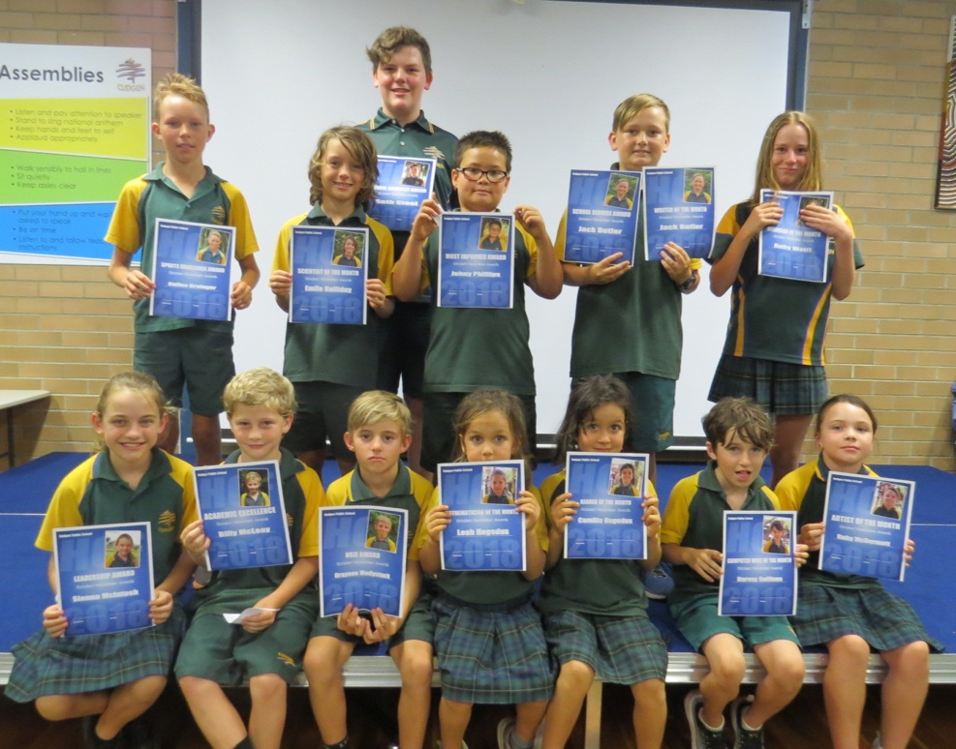

Swimming Age Champions Hall of Frames Awardees
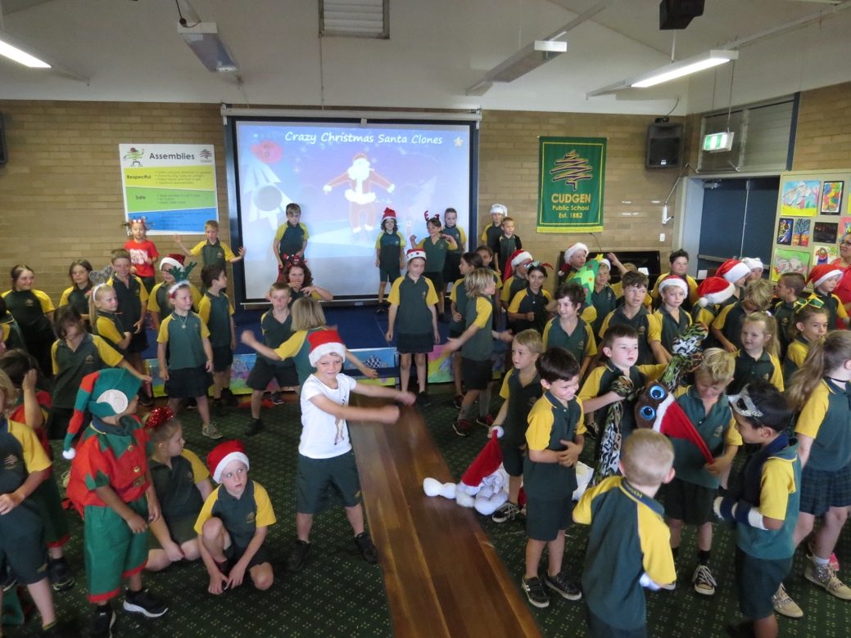
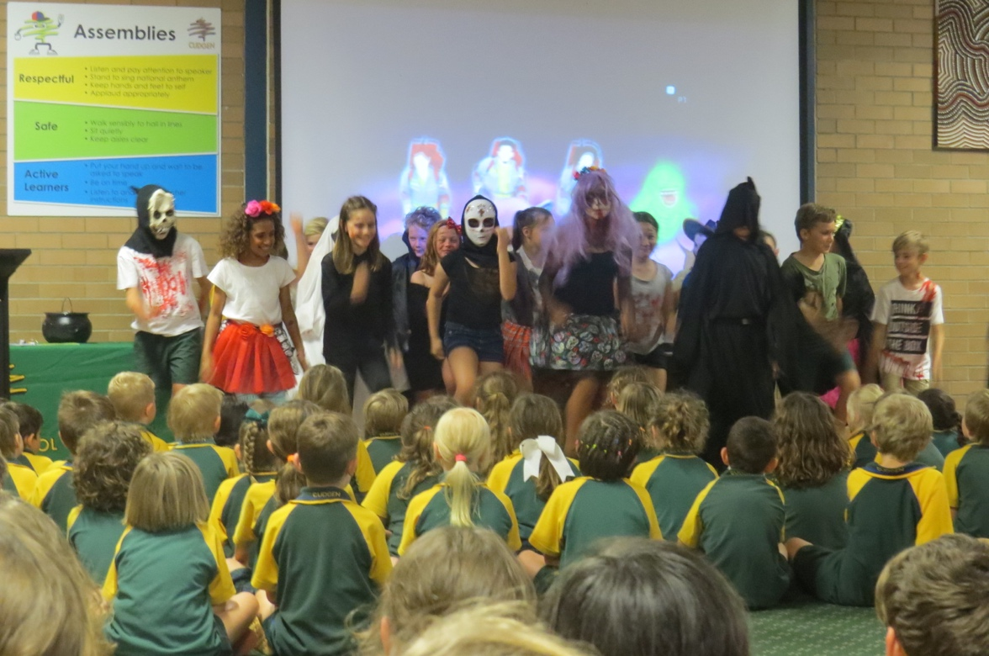

Assembly Class Item Kindy to Year 2 Xmas Concert

5. BEGINNING SCHOOL

Children who turn five before the 1st August in the first year are eligible to enrol at school. Compulsory enrolment is from 6 years of age.
From the beginning of school your child associates with a large number of children away from the home situation. Many activities in the early years and especially Kindergarten, encourage learning through play because learning in this way is natural, informal and allows interaction between children to take place. The teacher will be making observations in order to provide each child with stimulating and meaningful activities.

BE READY FOR SCHOOL
You can assist your child to be ready for school by teaching them . . .

- His/her name, address and phone number well enough to repeat them when necessary.
- The safest way to and from school.
- How to blow their noses properly.
- The importance of nose blowing in the prevention of ‘glue ear’. We have tissues for emergencies.
- The importance of hand washing before meals and after visiting the toilet.
- How to use and flush the toilet without assistance.
- About looking after property and how we put away playthings and materials after using them.
- How to tie own shoelaces.
- How to take off and put on outer clothing without help.

WHAT ELSE CAN YOU DO
Things you can do:

Talk to your child about school, new friends, games, songs and things they have made.
Buy clothes that are easy to manage. The buttons and button holes should be large. Coats and pullovers should have large loops so that they are easy to hang up.
Label CLEARLY, with FULL NAME, ALL possessions your child will take to school, eg. raincoat, hat, cardigan, parka, pullover, bag, case, plastic bottle, lunch box.
(This will save teachers a lot of time).
Send the child to school on time, each and every day if possible (8.45 am at the latest).
Give your child simple duties around the home. This will help to foster confidence in the performance of small tasks.
Consider allowing your child to stay with relatives or friends for short periods so that they accept the fact that it is not always possible to be with parents.
Encourage your child by admiring work when it is brought home. Give paintings and handiwork a place of honour for a few days at least.
Select suitable stories, picture books, radio and television programs for your child. Set rules on TV now and it will avoid problems later.
Encourage your child to participate in fruit breaks.
Teach your child sun-safe behaviours.

6 POSITIVE BEHAVIOUR FOR LEARNING

Cudgen is a PBL school and implements the Positive Behaviour for Learning framework (PBL). This process promotes the development of respect for self, others, property and our environment. It links in with the Cudgen School Welfare and Discipline Policy and actively teaches all the positive social skills and values we expect the students at our school to display/possess.

Our expectations:

Cudgen kids are: Respectful
Safe
And Active Learners

Each fortnight we have a PBL focus. This lesson is taught by all teachers every Monday after recess. The focus is practiced throughout the fortnight and students are rewarded with Captain Cudgen cards.

Captain Cudgen – is our school mascot and we have Captain Cudgen cards to reward positive behaviour. Teachers reward positive behaviour in the classroom and playground on a daily basis.
Captain Cudgen
__________________

Safe Active Respectful
Teacher

What are they?
Captain cards are used to acknowledge and encourage positive behaviour in line with our whole school matrix. They should reward positive behaviour and work attitude plus be used to acknowledge improved behaviour.

When are they given out?
Immediately, as soon as possible after the positive behaviour occurs. They can be given out in the classroom and in the playground. Each classroom has a container to post them in.

How many are given out?
Give out as many as possible. There is no limit on these, this helps to keep student on track and continually encourages positive behaviour in line with our whole school matrix and PBL focus for the fortnight.

Reward – each Friday 6 canteen vouchers/prizes are drawn at morning assembly.

There is also another ongoing classroom system called Cudgen Stars. This to reward consistent effort in the classroom but this is managed totally by each class teacher.

Assembly Awards
Each fortnight each class will give:
Student of the Week
2 Merit awards

SCHOOL FAIR DISCIPLINE CODE

CONSEQUENCES …………

Your teachers will reward good behaviour and ensure there are consequences for unacceptable behaviour. We will work with you and your parents / caregivers to support and develop positive social behaviour. Generally you will receive a friendly warning. If this behaviour is repeated more serious steps are taken and appropriate consequences are put in place. Our Student Welfare Policy clearly sets out the actions taken by your teachers, assistant principals and the principal. We believe strongly in involving your parents in this process in order to give you full support in reaching the high standards we set for our school. In extreme cases the principal will take immediate, strong, disciplinary action. These actions are in place to maintain a happy and safe school for everyone.

PROMOTING A HAPPY AND SAFE SCHOOL

A parent friendly overview of our . . .
Anti-Bullying Strategy – Be an upstander, not a bystander.
Student Welfare Policy
Discipline Code and
Behaviour Flowchart
Student Discipline

These policies are available in their detailed form if required by parents/caregivers.
Cudgen Public School is strongly committed to ensuring all students achieve their potential. To do this, students need to feel safe and secure. We have put into place various plans and procedures that encourage and acknowledge good behaviour and also address negative behaviour if and when it occurs.

Students who excel in a range of academic, social or sporting activities are recognised at monthly presentations called ‘Hall of Frames’ assemblies.

Inappropriate behaviour is tracked through an online student management system where teachers record incidents. These are sent to the assistant principal and consequences are put in place. Parents / caregivers are also informed. Parents are encouraged to support this process. With each incident, students reflect on their behaviour and are encouraged to learn from their mistakes turning negatives into positives. Students consistently displaying positive behaviours are acknowledged with Cudgen Stars and are rewarded with a Treat Day each term.

Cudgen Public does not tolerate bullying and we have procedures in place to address this issue. In classes we have programs that teach students skills and strategies allowing them to identify, cope and ultimately prevent bulling from occurring. These programs are available to parents if interested.

7. WHAT CHILDREN LEARN

To provide students with a broad and balanced education from Kindergarten to Year 6 (K-6) curriculum is defined in terms of six Key Learning Areas.

SIX KEY LEARNING AREAS

ENGLISH:
Students learn about and learn to use written language including Reading, Writing (including spelling and handwriting), Talking and Listening.

This involves developing the skills needed to read widely with understanding and enjoyment; to spell accurately; to write grammatically in a variety of forms; to understand the function of language; to listen and communicate effectively in a variety of situations and to assess critically, good literature.

MATHEMATICS:
Students develop the ability to investigate and solve problems.
This involves learning the basics of number, space and geometry, patterns and algebra, measurement and data; developing and calculating, reasoning, predicting and verifying skills; and gaining a foundation for future study of Mathematics.
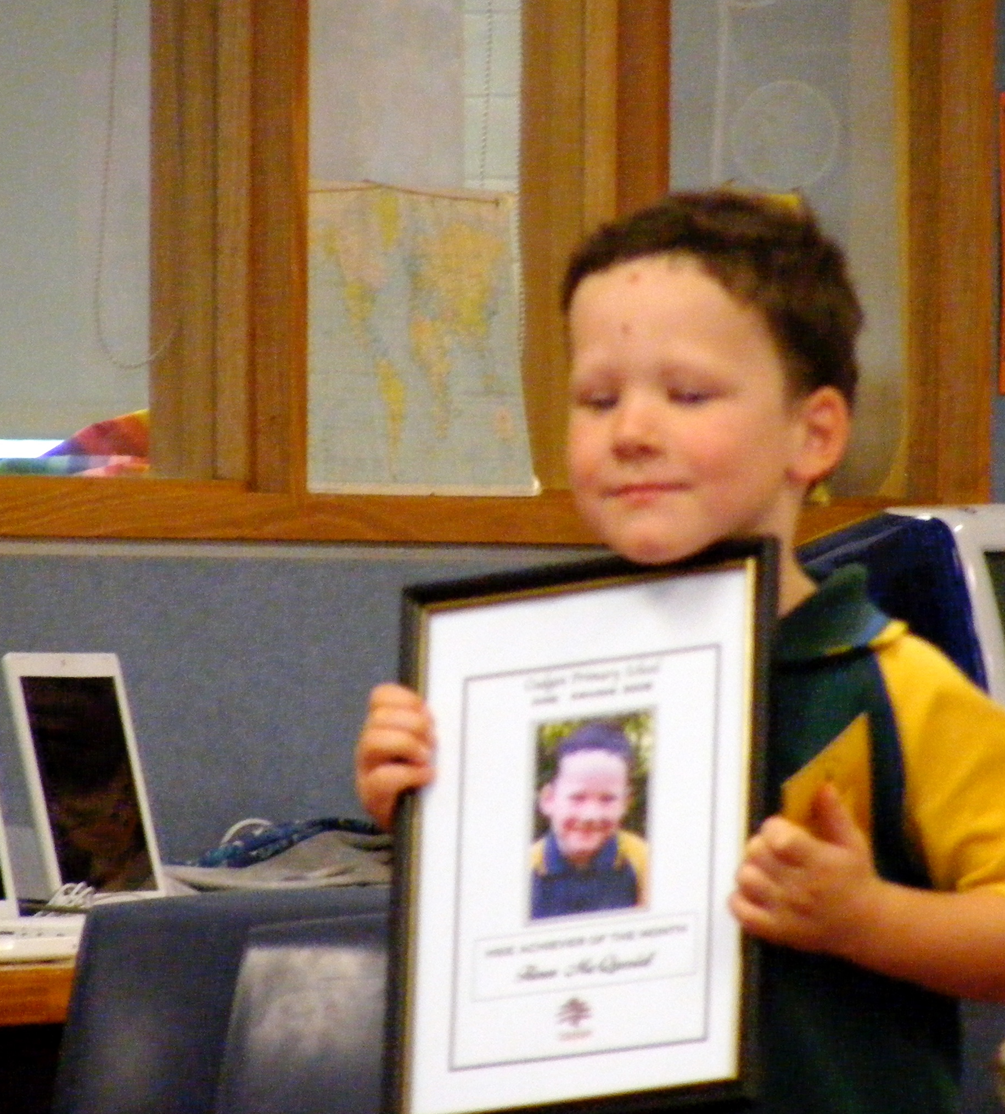
HUMAN SOCIETY & ITS ENVIRONMENT: (History/Geography)
This area deals with peoples' interactions with one another and with their social, cultural and physical environments. It involves learning skills of inquiry, investigation, designing and problem solving; gaining knowledge and understanding about the natural and modified environments and people’s interaction with them; acquiring knowledge of design processes; and understanding the interaction of technology and society. Computer Education is an important element in this Curriculum Area.

This key learning area also involves developing “communication and social skills:” gaining knowledge and understanding about the history of Australia; its geography, social institutions and places in the world; developing a commitment to maintaining or improving the environment; exploring, comparing and appreciating religious and moral beliefs and values; and learning about other cultures and languages.

SCIENCE AND TECHNOLOGY
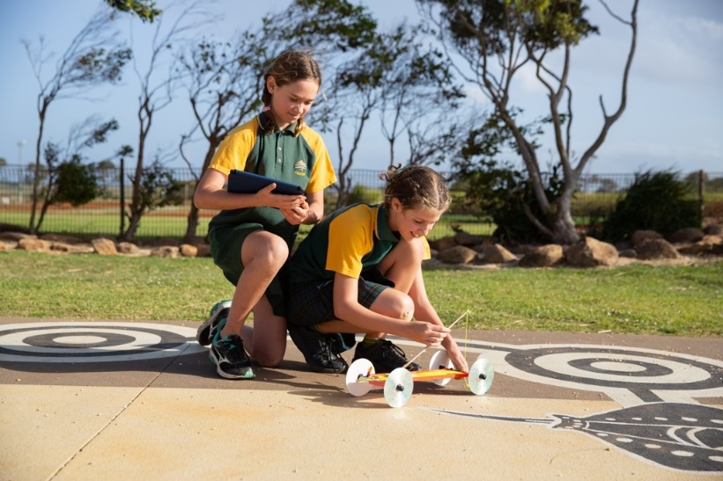
Students learn about natural and man-made environments. Students will develop their knowledge and understanding of: Built Environments, Information and Communications, Living Things, Physical Phenomena, Products and Services and the Earth and its Surroundings.

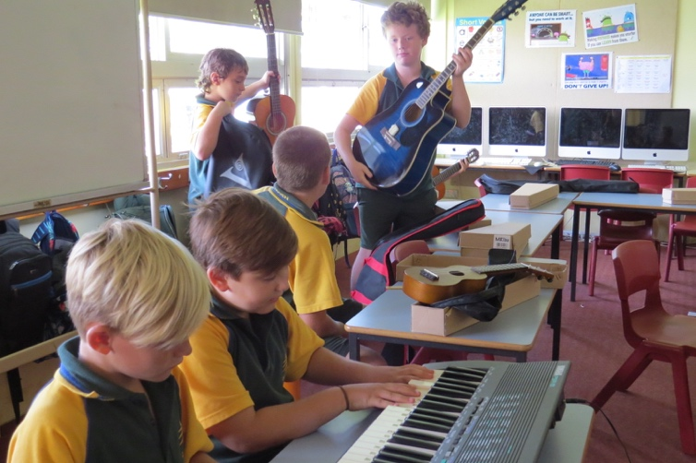
CREATIVE ARTS:
Students explore and experience different art forms including Dance, Drama, Music and Visual Arts. This involves developing technical competence and skills of designing and performing; and learning appreciation and self expression in these visual and practical arts. These programs are supported by choir, band, public speaking and verse speaking opportunities.

PERSONAL DEVELOPMENT, HEALTH AND PHYSICAL EDUCATION:
Students develop knowledge and understanding, skills, values and attitudes that will help them to adopt active, healthy and fulfilling lifestyles and skills in interpersonal relationships and positive values, attitudes and beliefs and participating in regular physical activity.

These key learning areas do not have equal time allocation. The greatest emphasis is given to English and Mathematics.
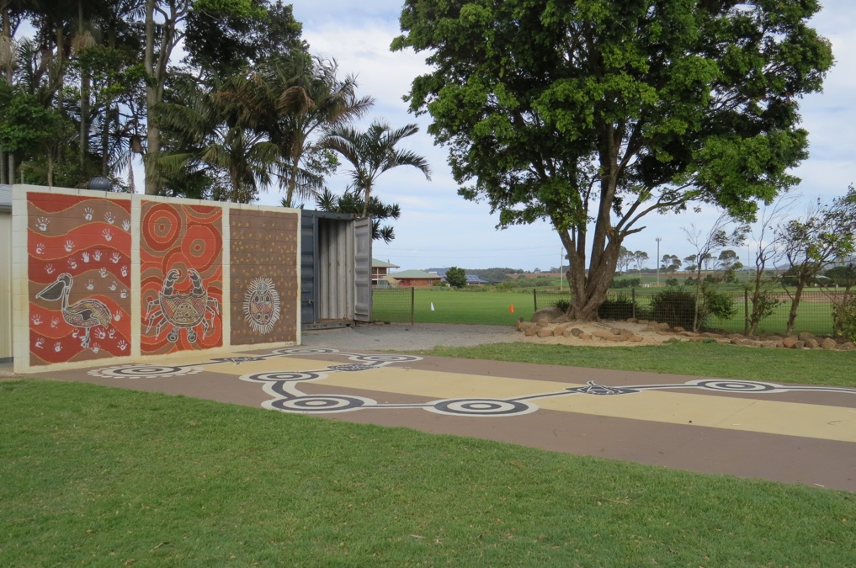
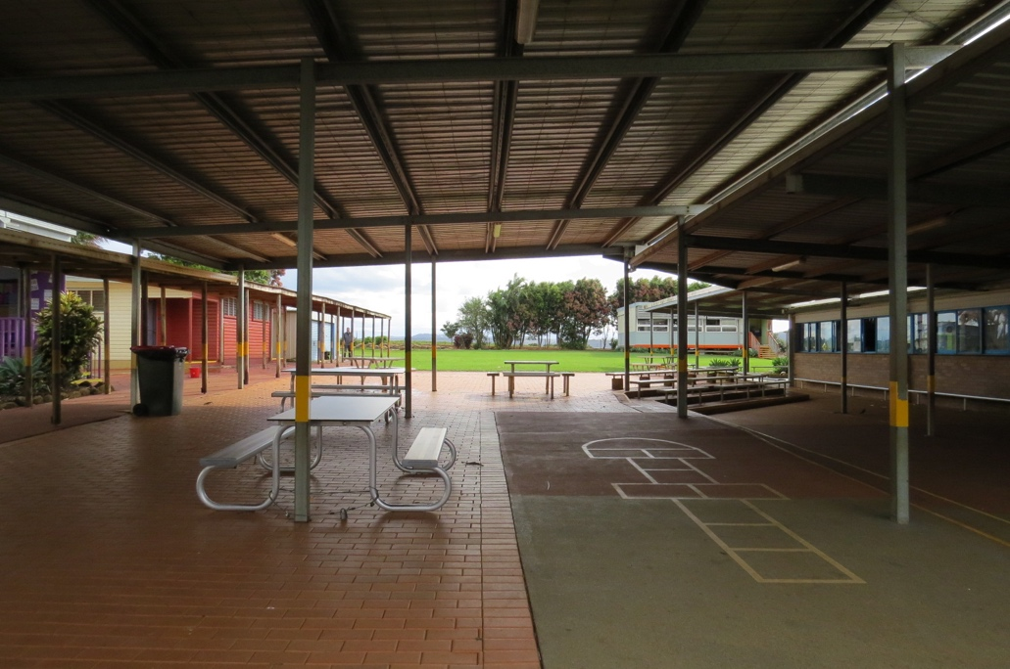
Students are also prepared for life outside of school through a range of programs that put learning in context, make it relevant and part of the culture of everyday school life.

OTHER PROGRAMS

These areas of learning include:
- Child Protection – as a component of PD/H/PE
- Indigenous Education
- Drug Education
- Environmental Education
- Gifted and Talented Education
- Multicultural Education
  - Anti-Racism Education
  - English as a Second Language (ESL) Education
  - Multicultural Perspectives to Curriculum
  - Supporting Students from Culturally Diverse Backgrounds
  - Community Relations
  - Music Groups – Recorder Karate, Choir, Percussion, Keyboard
  - Coodjingburra Culture Program
  - Dance Stage 3 – Cudgen Crew

- Religious Education
SRE is delivered on Thursday from 11.20 -11.50am for K-2 students and 11.50-12.20pm for students in Years 3-6. On enrolment parents/carers will be given the SRE participation letter to complete and return. After the initial enrolment, notification of changes to a child's enrolment in SRE should be given to your child's teacher, in writing.
- School Libraries
- School Sport - Cudgen Houses are determined by the 1st letter of students last name.
SPORTS HOUSES

Gurraman
I-Q
Gargoon
R-Z
Nhumahl A-H

COMPUTER EDUCATION PROGRAM
By the time students reach Year 6 this program will aim to develop students' computer skills and understanding in:
- using computer-based technologies to locate, access, evaluate, manipulate, create, store and retrieve information;
- communicating with others using computer-based technologies;
- discriminating in the choice and use of computer-based technologies for a given purpose and
- applying technology in all key learning areas.
A whole school teaching/learning sequence has been developed. Delivering this program, support and training of staff and maintaining hardware and software is done under the watchful eye of our school computer co-ordinator.
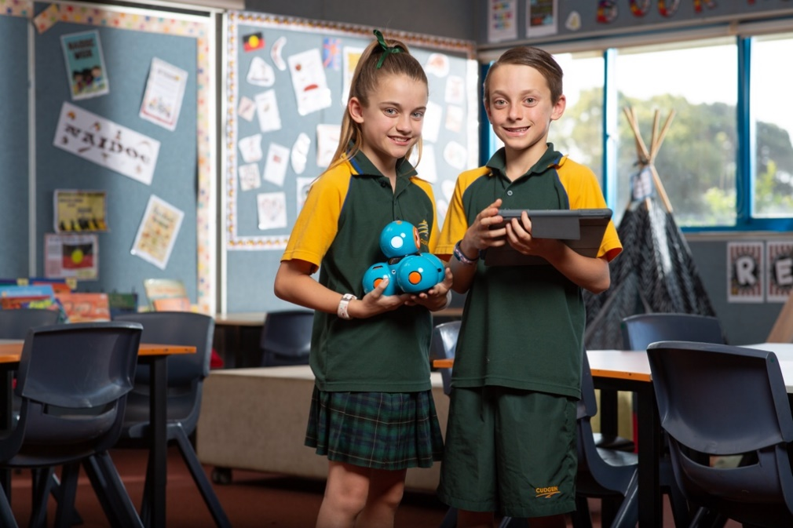
A wireless computer network operates throughout our school. Students are timetabled for regular lessons and have access to laptops, desktops and Ipads in their classrooms.
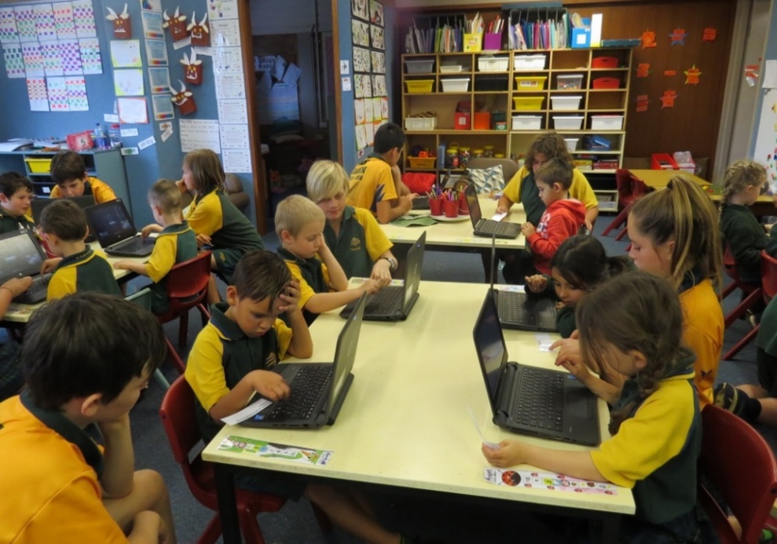

Swimming Carnival

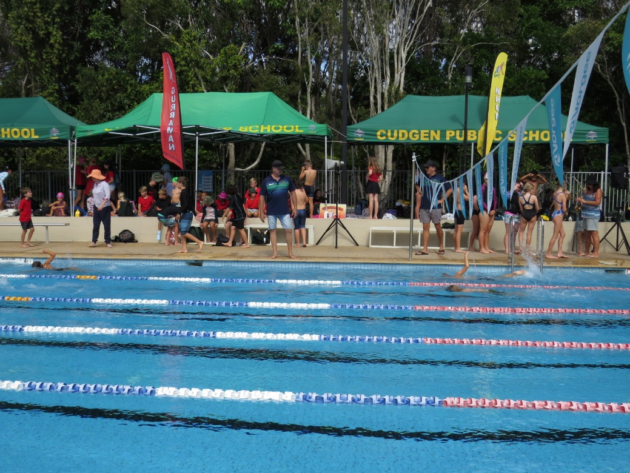

Grandparents Day

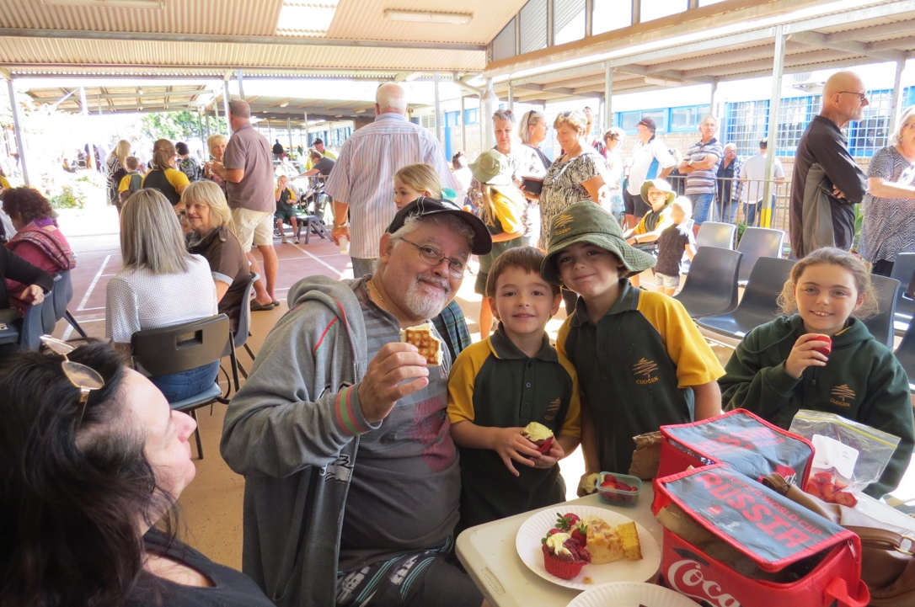
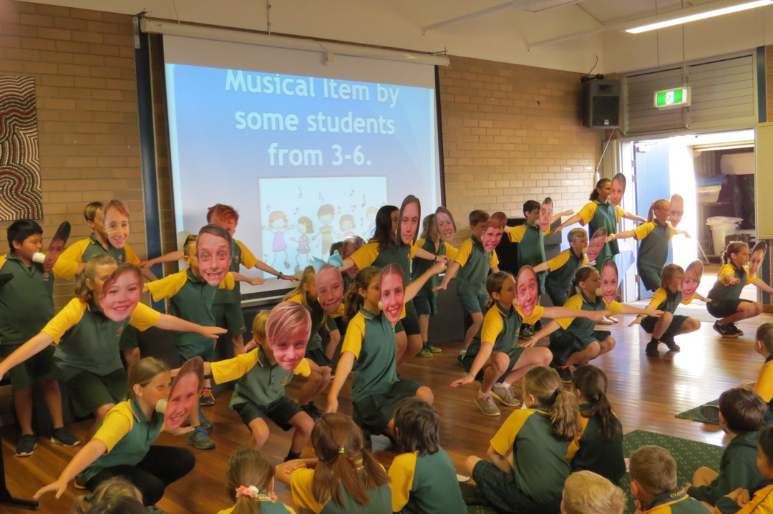

Mt Tamborine Excursion

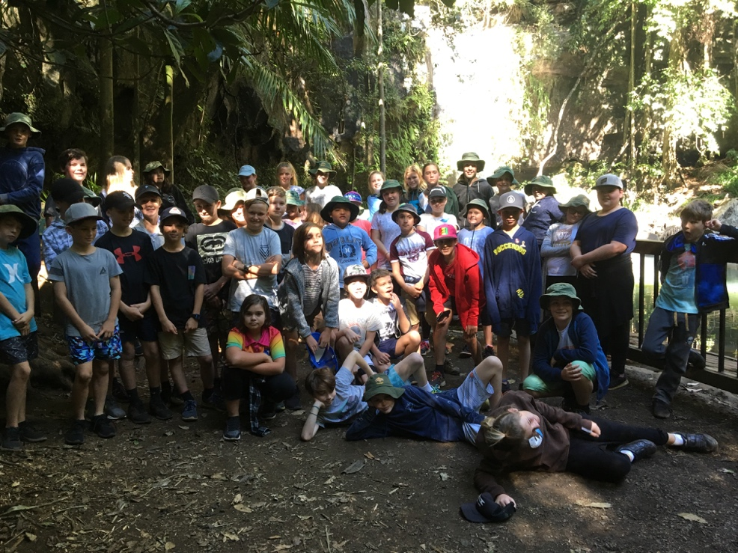
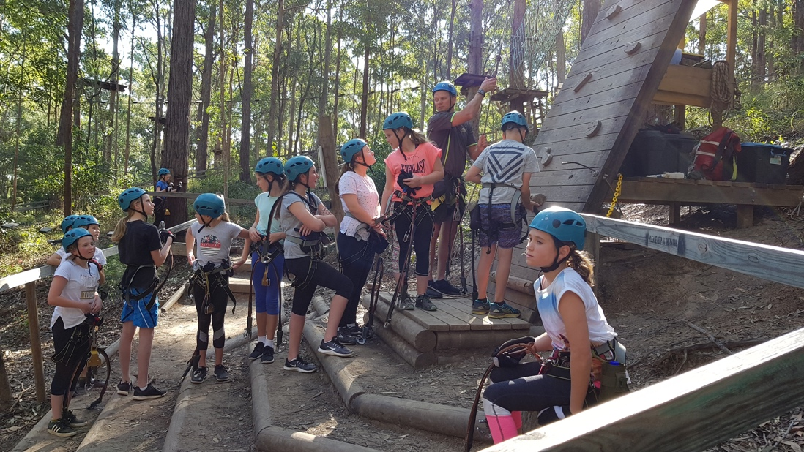

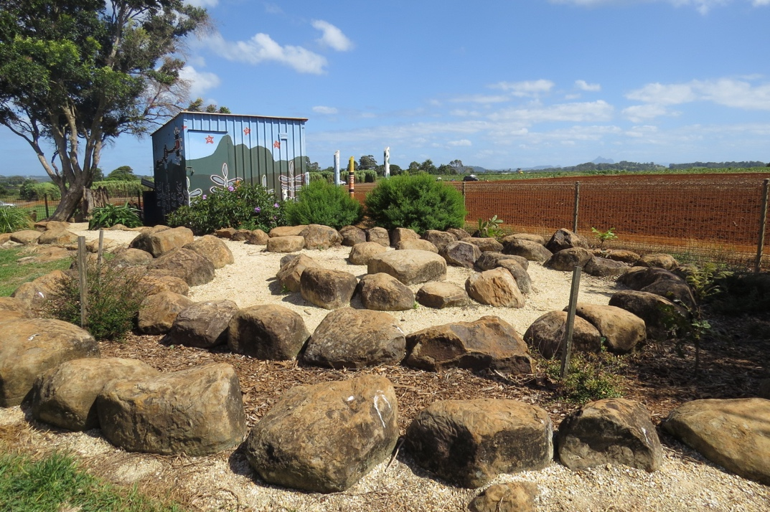
Athletics Age Champions Bush Tucker Garden

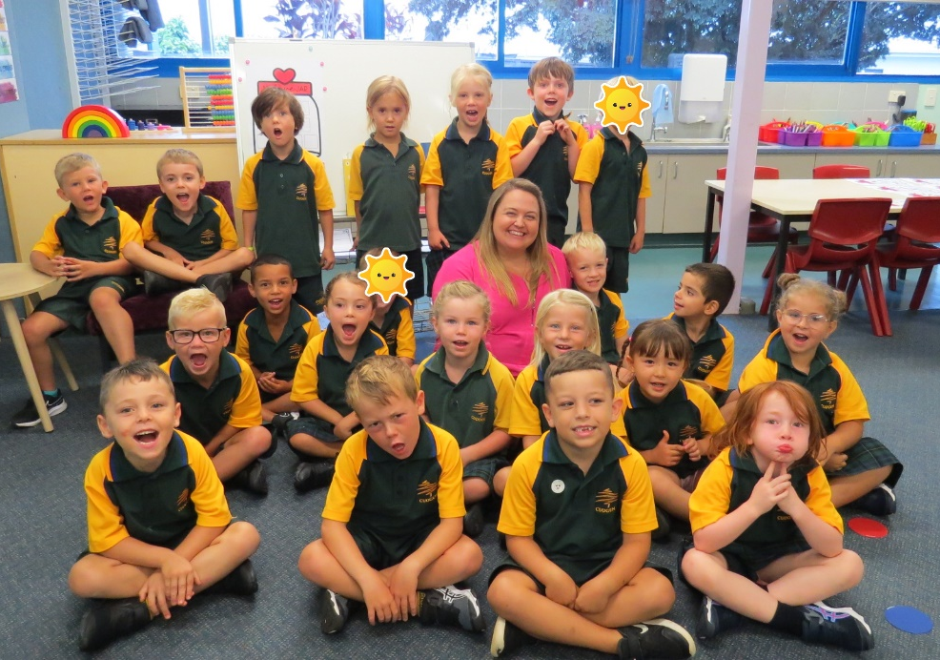
PBL Class Award Kindy
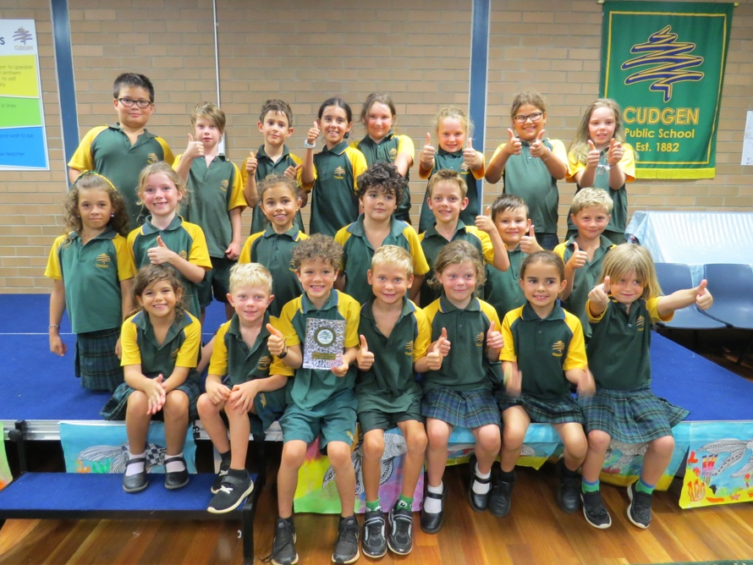

Years 5 & 6 Camp

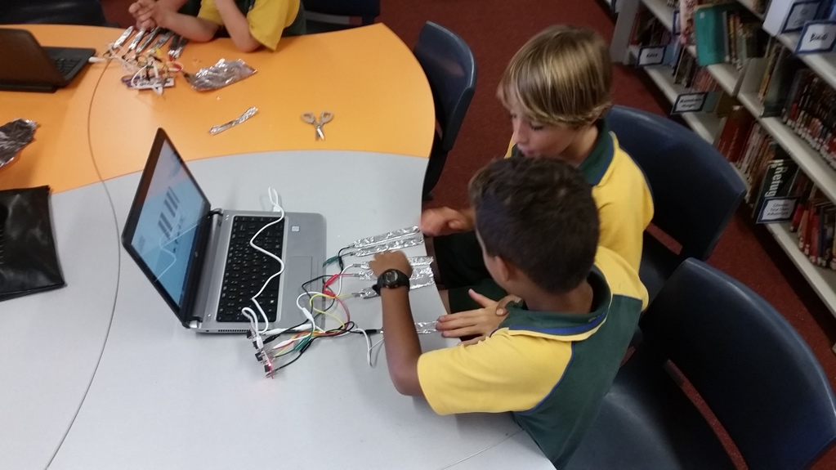
STEM

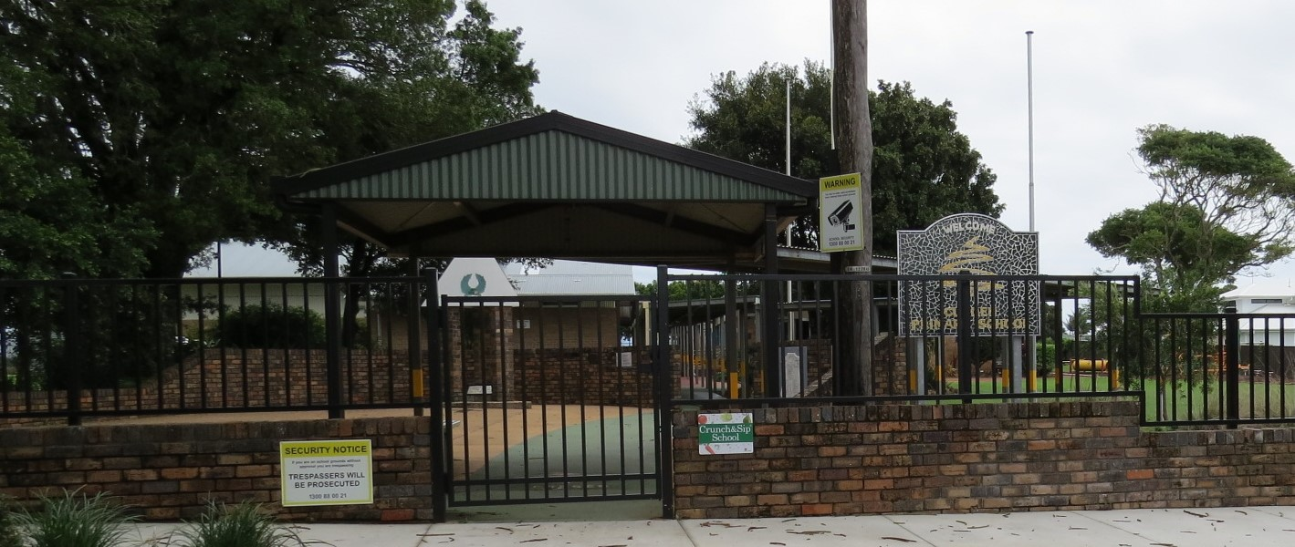

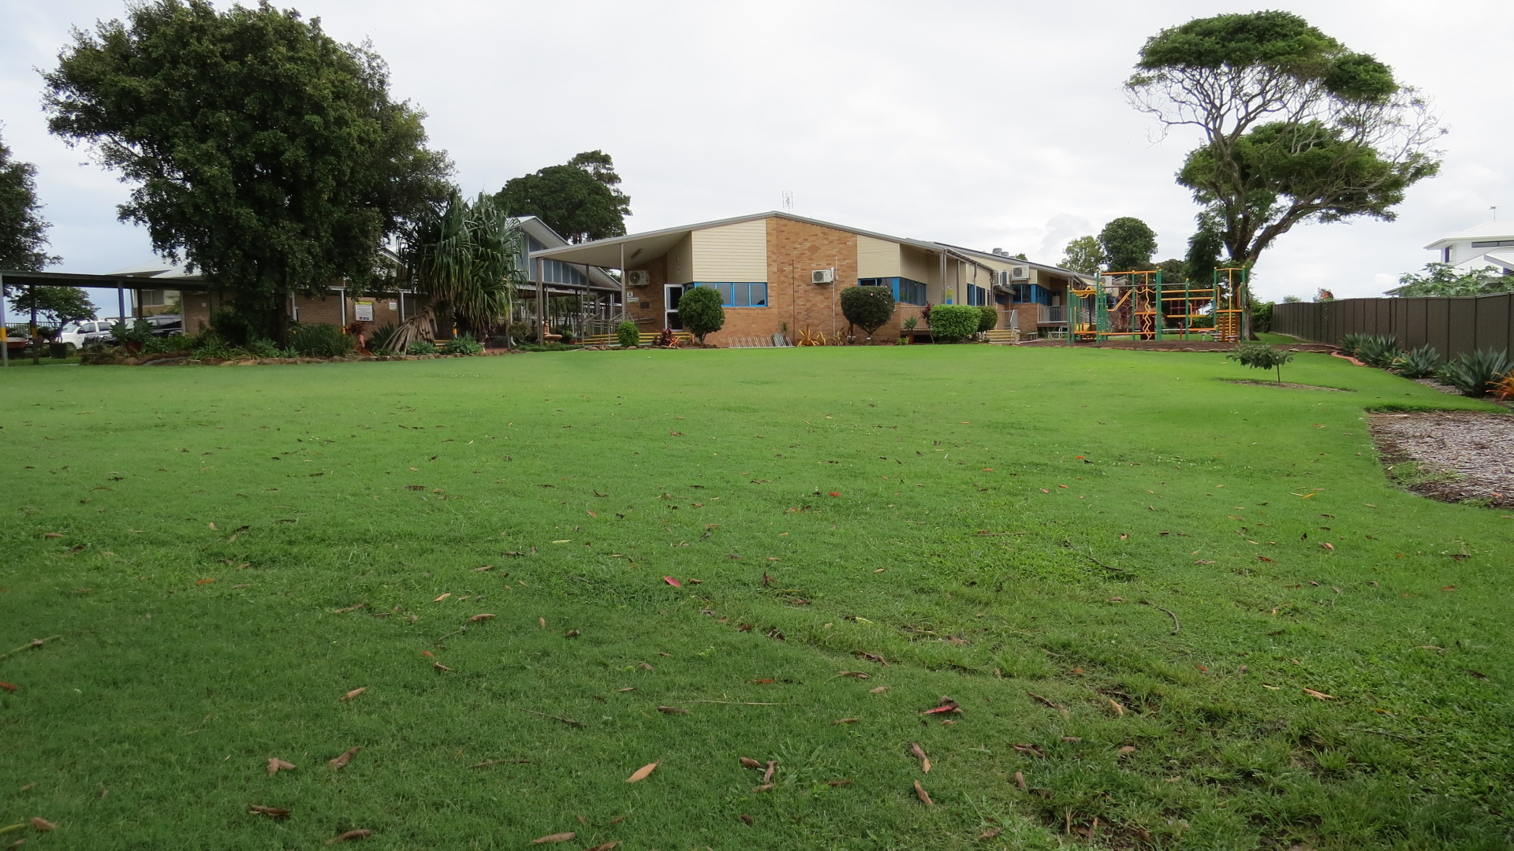

Reviewed Term 1: 2021
(Updated: 04/03/2021 by AD)

(Faculty/Teacher/2021/School Information Booklet T1 2021)

